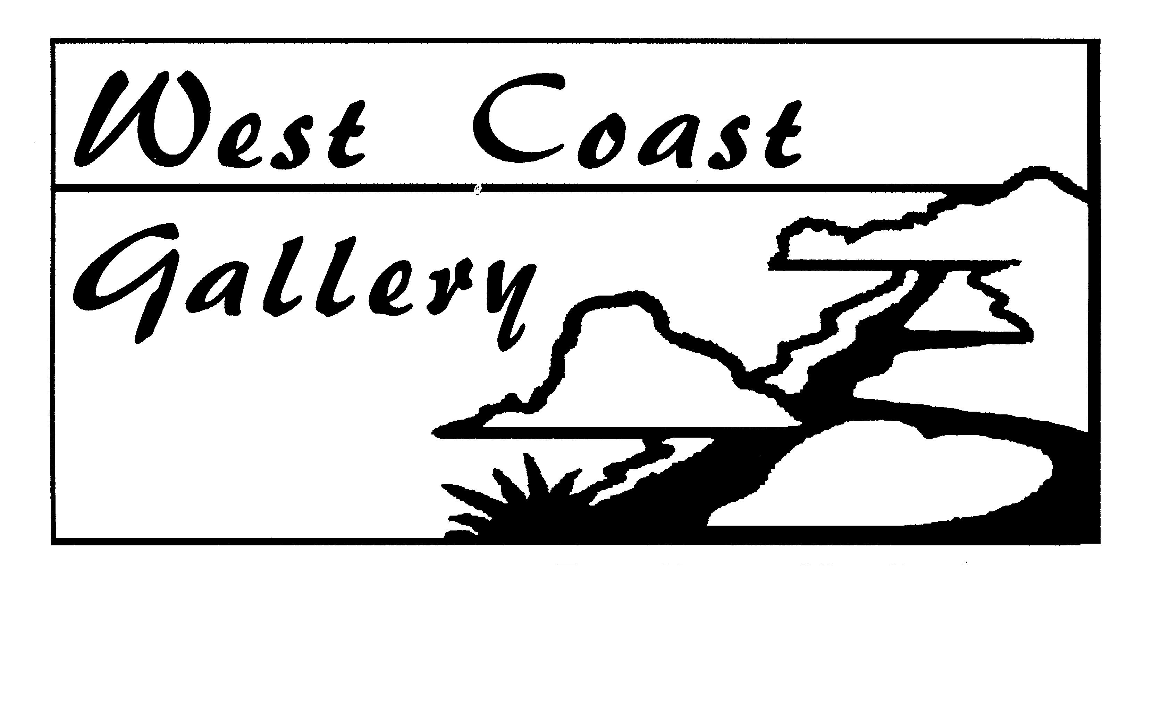

Summer hours
Wed – Sun. 10 – 5pm

Winter hours
Thurs – Sun 10 – 4pm
Or by appointment
www.westcoastgallery.co.nz

Old Fire Station
Seaview Rd, PIHA.
CMB 99, Piha. 0646
Ph 8128 029.

westcoastgallery@xtra.co.nz

3rd November – 2nd December 2012
OPENING: Saturday 3rd November, 2pm

“ROCK THE LION”

Images of Lion Rock by West Auckland Artists

* All mediums encouraged *

Entry Form

CONDITIONS OF ENTRY:

- Entry open to all gallery members and West Auckland residents
- Entry fee $10 per piece (no more than 2 pieces per person/artist)
Entry fee $5 per piece (for children – up to 15yrs.)
- Work to be ready for hanging/display and for sale.
- 30% commission will be charged on sales.
- Committee’s decision will be final as to which pieces will be chosen for display
- Entries to be at the gallery with completed entry forms by Sunday 28th October (absolute latest Wednesday 31st Oct. by 11am.)
- Unsold work to be collected from the gallery by Wednesday 5th December
- Work not accepted must be picked up the weekend of the 3rd/4th Nov (we do not have the storage space)
- Recommended size restriction - at co-ordinator’s discretion.

NAME…………………………………………………………………………………………

ADDRESS……………………………………………………………………………………

EMAIL ………………………………………………………………………………………

PHONE………………………..…………..MOB……………………………………………

No. of entries……….. @$10 each ($5 child) Paid $……………….

Is the work individually named and priced? Y/N

TITLE OF WORK………………………………………………………..RETAIL PRICE………

TITLE OF WORK………………………………………………………..RETAIL PRICE………

