Go the Mighty Piha Machine. Piha NZ Champions yet again. Results from NZ Champs -

Thanks to those that support us. Those that don't I need to have a chat.

Seriously Piha leading into the 2011 - 2012 year needs your support more so than ever. We are getting the results but it is becoming increasingly hard without outside support. Come join us and be part of the party. Use our club and enjoy the beautiful beach with our fantastic members risking their live's to save others.

If you can help please contact me. Im sure we can come to an arrangement. It is a huge expense to put guards on our beach and to give our members the opportunity to achieve as they do. Like in business we do expect excellence.

Thanks

Peter Brown
President Piha SLSC

 Piha – NZ Champions

1st Champion Surf Boat Club – Burger Fuel -Piha Boaties

1st Open Men’s LC Champions – Burger Fuel- Piha A Crew
1st Open Men’s SC Champions – Burger Fuel- Piha A Crew
1st Best Team NZ Nationals – Burger Fuel- Piha A Crew

1st Under 23’s Colts LC Champions – Burger Fuel -Piha Pirates
1st Under 23’s Colts SC Champions – Burger Fuel -Piha Pirates

2nd U23 Colts SC – Burger Fuel -Piha Pistols
2nd U21 Women SC – Burger Fuel -Piha Colada’s
3rd U21 Women LC – Burger Fuel - Piha Colada’s
3rd U19 Men LC – Burger Fuel - Piha Chargers



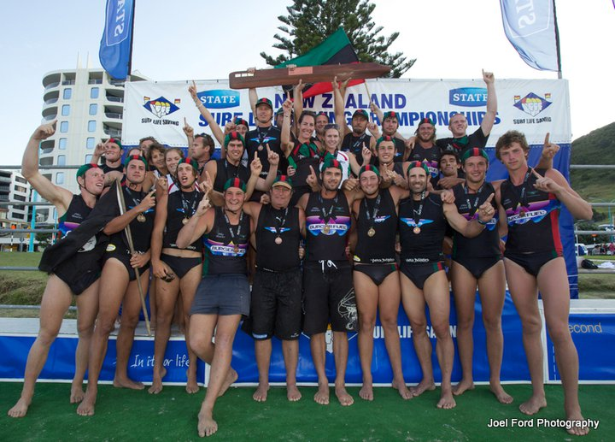

The Beaut weather made for a perfect National Champs apart from the washed out Saturday with the tsunami warning in place all day ! That just made the Piha Crews now facing double racing Sunday dig a little deeper, With their valued Champion boat club status on line ( for the forth consecutive year now ! ) and multiple other medals up for grabs the Piha Crews , with 7 Crews attending Horse, Bugsey , Phil & Alice had their work cut out ( especially when Alice had to row with a late pull out from the ladies ! ) The battle was on, thick and fast the other NZ crews did their best to upset the Piha Machine. Not only did the Piha Crews hang on to the Fiercely disputed Club Champs but the Pirates took out a double , the Girls a 2 x medal haul and the Ultimate - Blue ribbon event of the carnival the Senior men’s finals, these hotly contested races with Hot Favourites & arch rivals Titahi Bay chasing an historical 4th consecutive title in Long course were always going to be screamers. Well the Piha A Crew knocked the buggar off as they say and dethroned the Champions to be the Big Show in Town.

OPEN MEN’s : The Story can’t get any better than this, The current Champions ( Titahi bay ) had not lost a race all season, they had beaten the Best crew in Australia over 9 races and were chasing their 4th consecutive title in LC ( and would become the first & possibly greatest crew to ever do so... NOT ! ) The Mighty Piha A Crew decided it was time to dethrone these guys and not only did they do it once but twice in Long & Short course racing, Horse , Knoxy, Bruce, Big Matt & Ben had worked a plan all year to bring about this moment and what a sweet moment it was, Especially meaningful as Knoxy & Bruce ( Poss Matt ) announced their retirement after knoxy 20 years ( Bruce 18 yrs ) rowing for the Mighty Piha Club . This is the greatest achievement that a surf boat crew can gain and never before has Piha been at these heights. Also to be able to complete this historic double in the 100 year centenary of SLSNZ the moment will be well recorded by all.
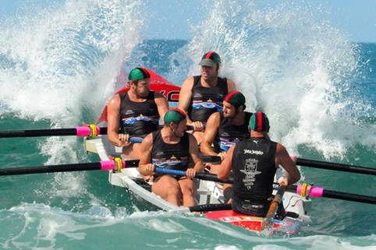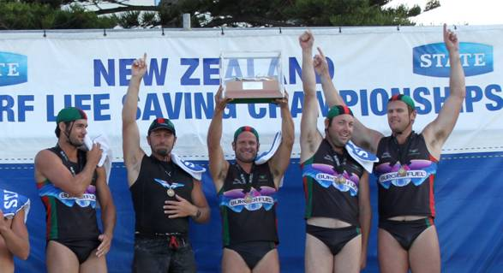

Piha Boomers : The Boomers had prepared well and were obviously going to feel their lose of Bingo Morris and the return of Hugh ( who had been overseas and out of the boat for some time ) but the boys got stuck in none the less, The first days Short course couldn’t have been any more unkind to the crew with 2 lots of finishing having them hit the beach on the same wave as 4 other boats but get to the flag last ! down but not out the Boomers fought back during the long course racing to gain a well earned Semi final spot and just missed the Final by a whisker , a good effort from Bugsey, Simo, Hugh, Hayden & Simo.
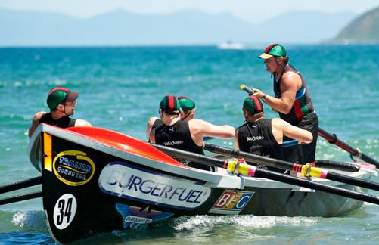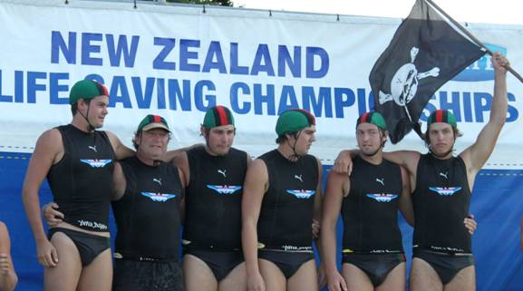

OPEN WOMEN’s : The Piha Ladies crew had to change a few things when the Nat’s moved from CHCH and one of the key rowers wasn’t available, Alice the Sweep had to row and Bugsey adjusted his already heavy workload to steer the Ladies over the competition, Just missing the SC Semi’s by a count back point the ladies worked harder to make the Long Course semi finals, Not a bad effort with the adjusted crew, The Ladies missed the finals unfortunately and a shame that the change of venues effected their ability on the water with the crew change, But the ladies put in plenty of work during the season and luck wasn’t on their side often, A big thanks to Alice, Aimee, Katrina & Annelies for the season & Bugs for his efforts at Nats,
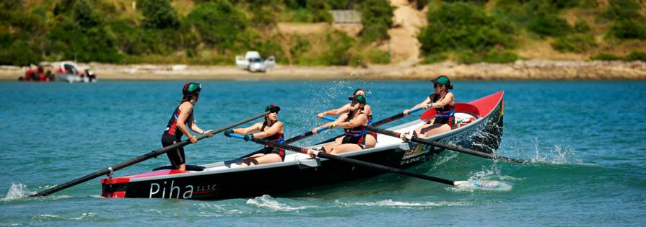

U23 MEN’s : The Piha Pirates worked hard at the best result a crew could hope for at the Nationals, double Gold’s. Both Long Course & Short Course were picked up by the Pirates to cap an outstanding season. With the 3 day comp being pushed into two days the boys were well placed with the 5th man and juggled that to suit their needs as race after race played out, The Pirates had plenty of go in their boat and worked their way into both Semi’s to be placed for the big one, The Boys made easy work of the Long Course and the Short Course whilst closer wasn’t going to get away from them with all the great work they have done this season. A very tight unit and all their hard work paid off in spades. I believe most of the boys are back next year in the same division.. plenty for the opposition crews to think about !! Great row by Mus, Nick, Jed, Adam, Logan & Bugsey .

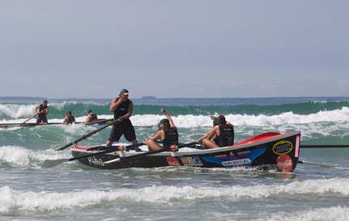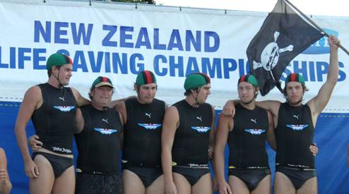

U23 MEN’s : The Piha Pistols had a mixed event, Finishing top qualifier in Long course meant a centre lane start, but the final was all over the first few metres when the first two alleys got out clean and all other 4 got smacked, all over at that Point, the inside alleys had top performing crews and giving away a couple of lengths at that point meant she was done & dusted. The Short course was allot closer when the Pistols came home on the same wave as the winning Pirates, Pirates sprint superstar Logan wasn’t going to let the double slip and Pistols got the second spot. At the end of it all the Guys got out of the season what they put into the season, well short of their best efforts in previous years at the Nationals. So plenty to reflect upon if the Pistols want back their winning ways next year ?
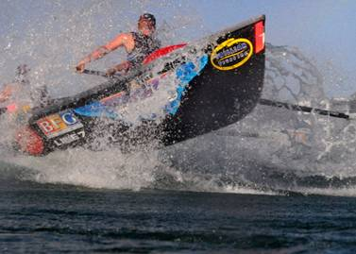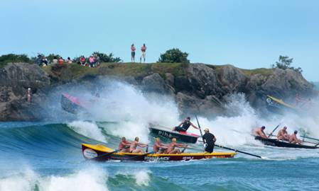

U21 WOMEN”S : The Piha Colada’s had one medal from Last season’s Nationals and were keen to increase their claim this time around, The extremely competitive U21 women’s racing was deadly tight finishing all the way along, with 12 crews competing for only 6 final spots they had to be on their game, Phil and the girls managed both finals on Sunday and did their best to increase their previous medal haul, a second on Short Course was a bonus as they missed these medals last season and the bronze they grabbed in Long Course was just shy of their target but in the extremely competitive field a top result. Claudia, Audrey, Gracie & Alice had a great event and Phil managed to keep his sanity through the season, well done.
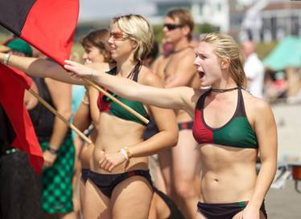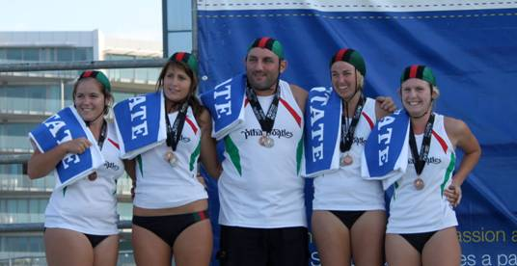

U19 MEN’S : The Piha Chargers had their first ever Nationals and had plenty to do entering 4 divisional races, the guys managed both of their perspective finals with both Long & Short Course achieved amongst the very competitive age group of 19’s, the first final LC was a difficult race and the boys did their best to stay on the pace, the well respected 3rd placing was the end result, the guys did suffer from a lack of finals preparation with one of the mina rowers based out of Dunedin the final 5 weeks prep. Short course just slipped away when the guys although in a handy position didn’t manage to get up the beach as handy as other crews and got just pushed into 4th Position. Another good example however of a crew who got out what they put into things ??
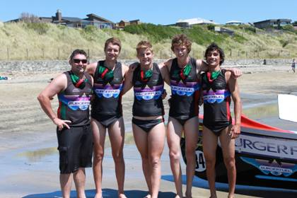

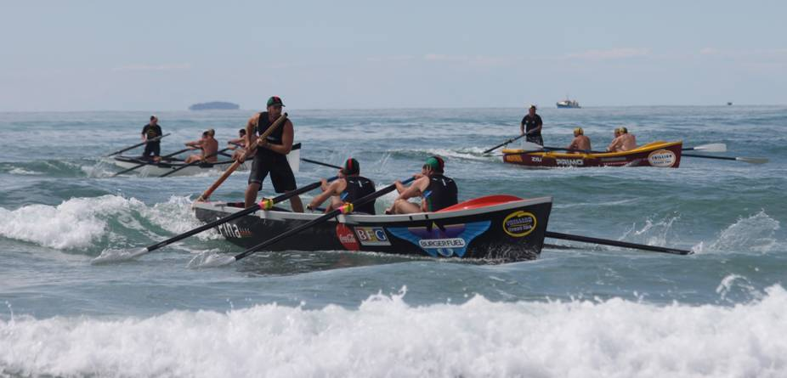

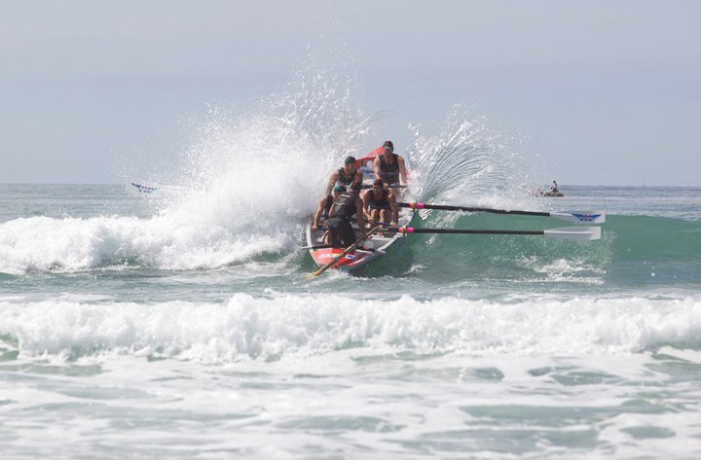

HORSE

Piha Boat Captain



